TTM 4150
Internet Network Architecture

Exercise 3: “The simulation of IP Network with NS2”

David Rozas Domingo
Maria Fernandez Rodriguez
Youzhang Liu
Task 1

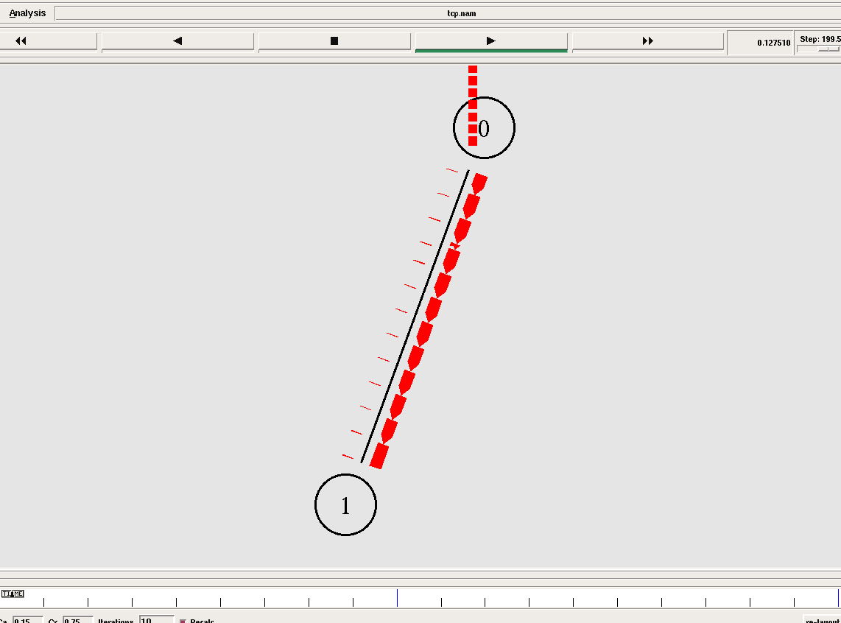

The traffic goes from 0 to 1 normally, and we can see the node 0 is buffering some of the packages because of the slow start control congestion mode.
Task 2

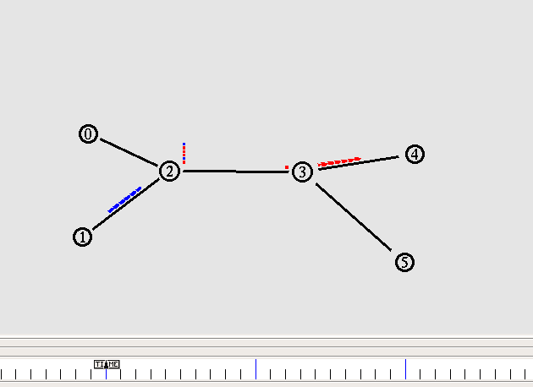

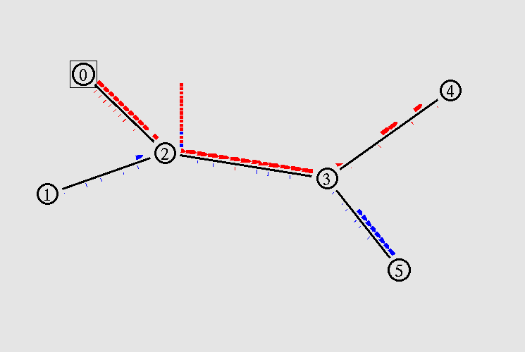

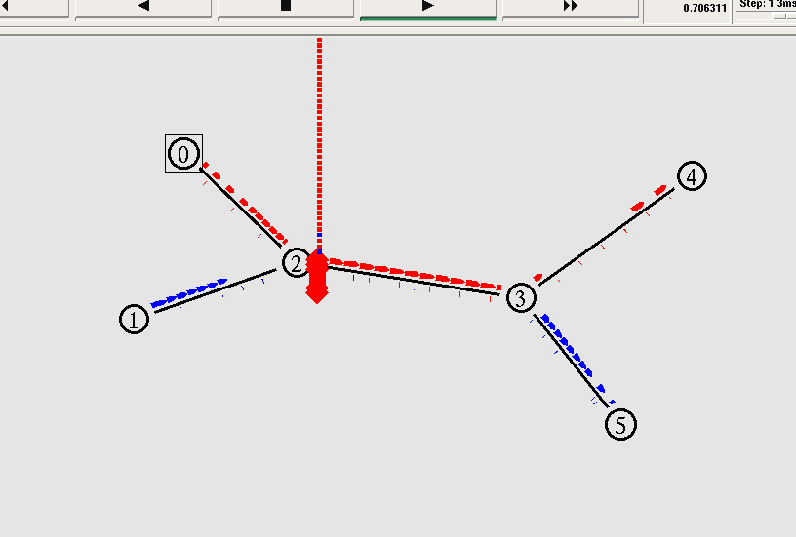
In this sequence of screenshots we can see:
- Nodes 0 and 1 are generating packages with a rate of 1460 B every 0.003 seconds
- Nodes 0 and 1 start sending packages with a slow start in order to control congestion, so they start sending packages with a slower rate than 1460B each 0.003 seconds. Node 1 starts after 0.3 seconds of the starting of the simulation (screenshot 2.1).
- Node 0 is generating more packages than it is sending because of the slow start at the beginning.
- When the rate from node 0 is bigger than 1460B every 0.003 seconds, then node 2 is receiving traffic from 0 and 1, its buffer starts to accumalate packages. (screenshot 2.2)
- When the buffer is overloaded, node 2 starts to drop packages.. (screenshot 2.3)

Task 3

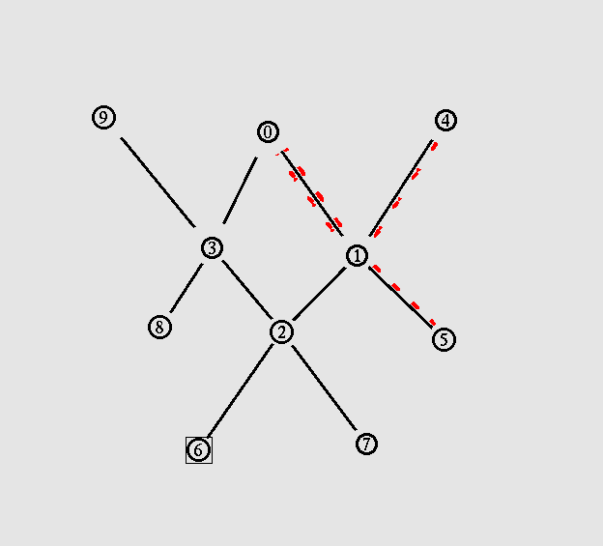
In multicast there is only one connection from the source, and we have to set up a “rendez-vous” node. The servers which are interested in receiving the traffic should join the multicast group (in this case is only node number 5).
Therefore in this case the traffic from 4 to 5 goes in this way: 4->1->0->1->5.

Task 4

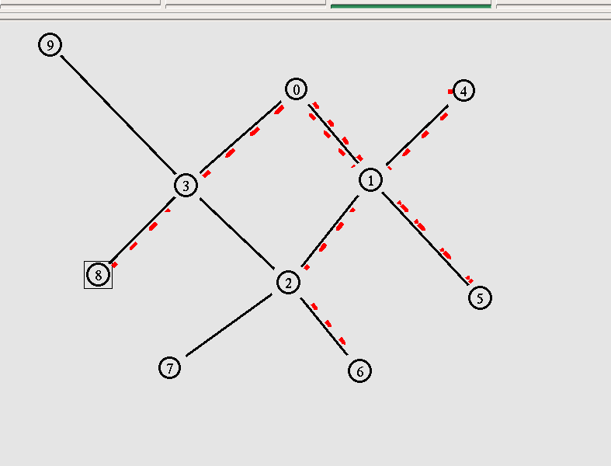
In this case we can see that the traffic is being sent to nodes 8, 6 and 5.

Multicast Tree:
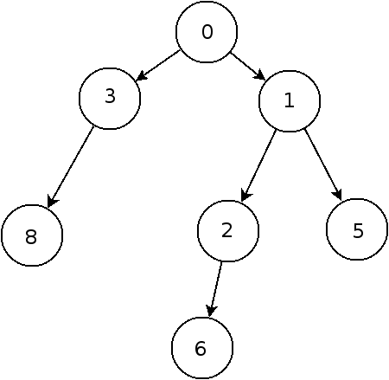

Calculate bandwith:

The bandwith for one link is:

1460 B/ 0.003 s = 486666 B/s

We are using 7 links, but one of them (0-1) is used twice, therefore the bandwith used for the multicast network is:

486666 B/s x 8 links = 3893328 B/s

The capacity of one link is 10 Mb/s, therefore the capacity for the multicast network is
10Mb/s x 10 links = 100 Mb/s = 100 MB/s = 104857600 B/s

Therefore the bandwith/capacity rate is:

3893328 / 104857600 = 0.037129669 (We are using a 3.71% of the network capacity for the multicast traffic).

Suggestion for improving the bandwith/capacity rate:

We could reduce the number of links setting node 1 as “rendez-vous” node. In this way the number of links would be 7, so the bandwith would be

486666 B/s x 7 links = 3406662 B/s

and the badwith/capacity rate would be:

3406662 / 104857600 = 0.032488461 (We are using a 3.24 % of the network capacity for the multicast traffic).

So the traffic would be reduced in 0.037129669 - 0.032488461 = 0.004641208 (a 0.46% less)

Task 5

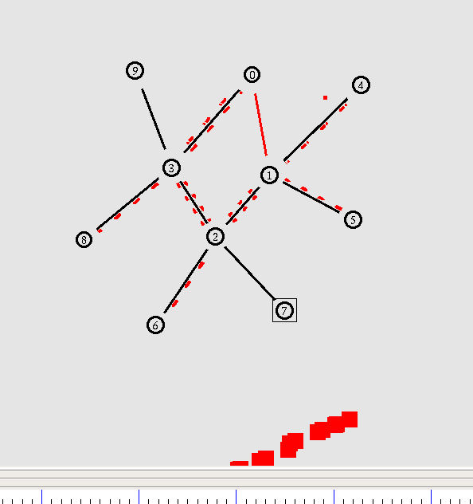
Here we can see how the traffic is being sent to the sinks once the link is broken.

Multicast Tree:

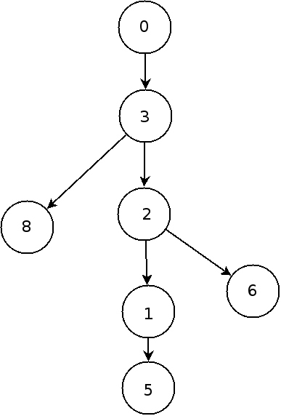

Calculate bandwith:

The bandwith for one link is:

1460 B/ 0.003 s = 486666 B/s

We are using 10 links, but some of them (0-3,3-2,1-2) are used twice, therefore the bandwith used for the multicast network is:

486666 B/s x 10 links = 4866660 B/s

The capacity of one link is 10 Mb/s, therefore the capacity for the multicast network is
10Mb/s x 10 links = 100 Mb/s = 100 MB/s = 104857600 B/s

Therefore the bandwith/capacity rate is:

4866660 / 104857600 = 0.046412086 (We are using a 4.64% of the network capacity for the multicast traffic).

Comparison with an unicast solution:

The unicast solution would use less links, but the source should keep more connections; so the bandwith support by the 4-1 nodes link would be overloaded because we would need 3 connections, and therefore 3 streams.
This is the advantage of the multicast solution: we have only one stream and the source server and its links are not going to be so overloaded.

